**TASK-4**

**Q1: Write a program to print the pattern given below  
\***

**\* \***

**\* * \***

**\* * * \***

**\* * * * \***

**PROGRAM**

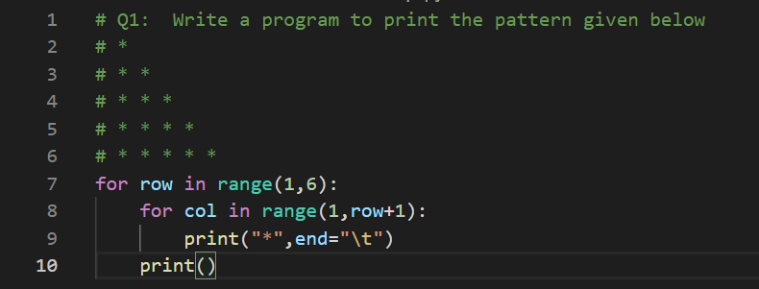

**OUTPUT  
  
Q2: Write a program to print the pattern given below  
1   
1 2   
1 2 3  
1 2 3 4   
1 2 3 4 5  
PROGRAM**

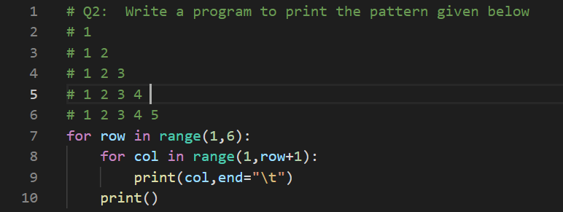

**OUTPUT**

**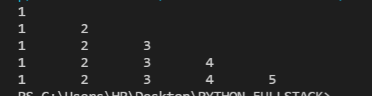  
Q3: Write a program to print the pattern given below    
*  
* *  
* * *  
* * * *  
* * * * *  
* * * *  
* * *  
* *  
\***

**PROGRAM**

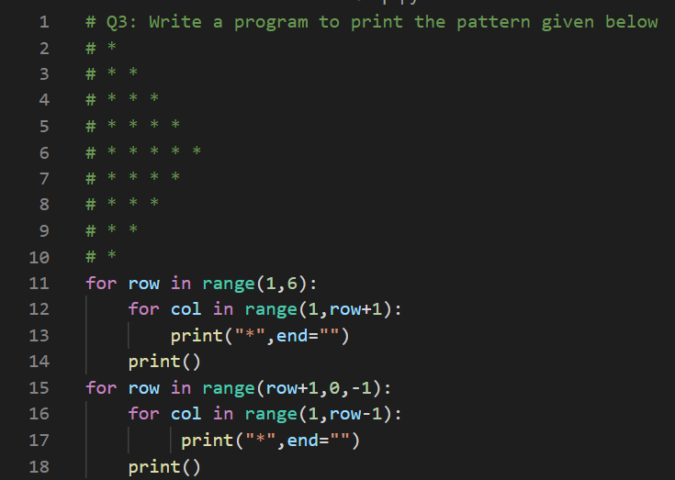

**OUTPUT  
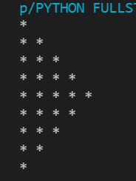  
Q4: Write a Python program to create the multiplication table (from 1 to 10) of a number.**

**PROGRAM**

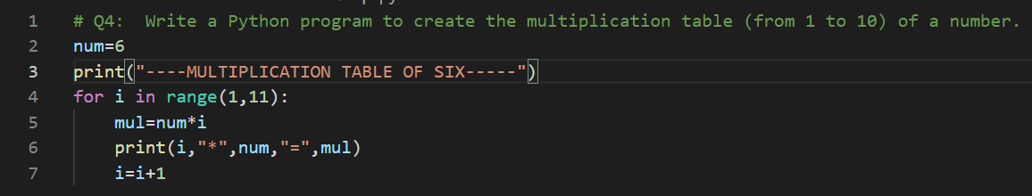

**OUTPUT**

